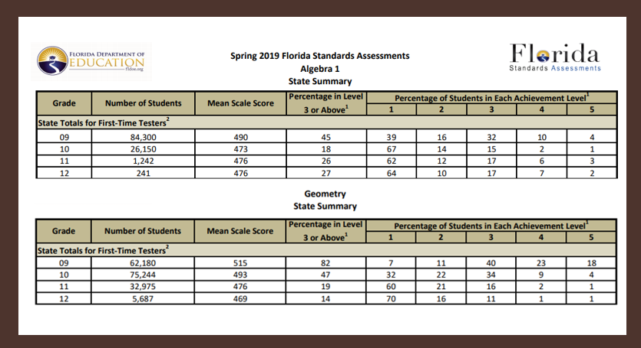

|  |  |
| --- | --- |
| **What do you notice?** | **What do you wonder?** |
|  |  |

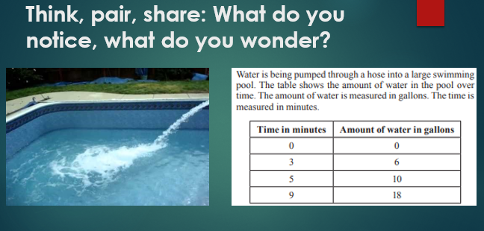

|  |  |
| --- | --- |
| **What do you notice?** | **What do you wonder?** |
|  |  |

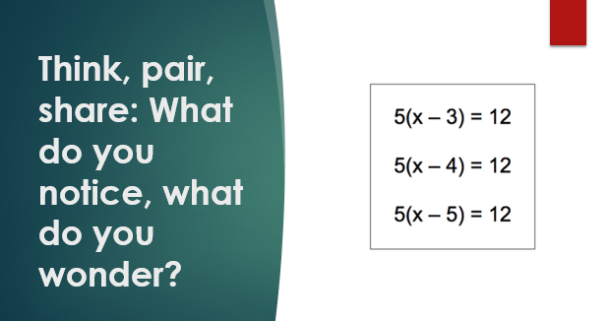

|  |  |
| --- | --- |
| **What do you notice?** | **What do you wonder?** |
|  |  |

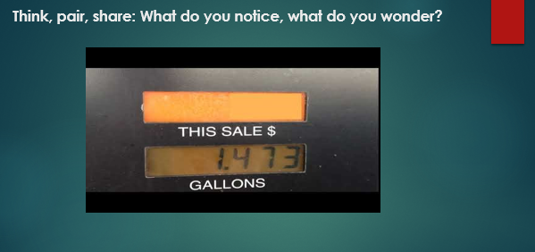

|  |  |
| --- | --- |
| **What do you notice?** | **What do you wonder?** |
|  |  |

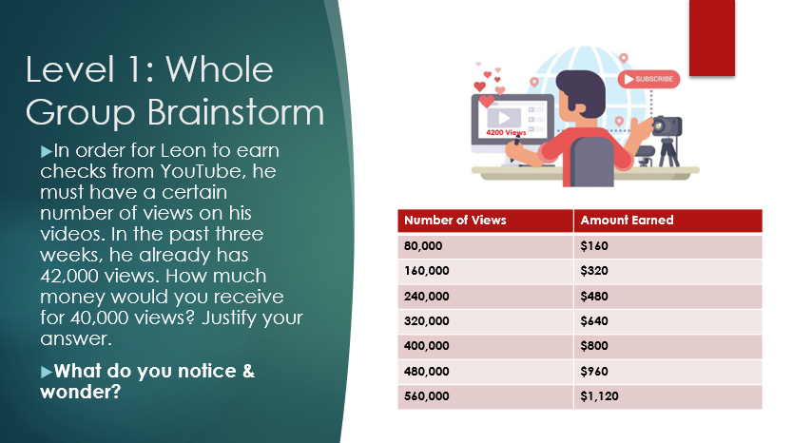

|  |  |
| --- | --- |
| **What do you notice?** | **What do you wonder?** |
|  |  |